**Bootstrap well component** gives the content inside it, the sunken effect. This component is generally used to make a section of the content on the page to stand out from the rest of the content.  
  
**Creating a well :** To create a well, create a <div> element with class well and place your content inside it.   
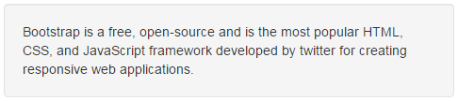

<div class="well">

    Bootstrap is a free, open-source and is the most popular HTML, CSS, and JavaScript framework developed by twitter for creating responsive web applications.

</div>

**Creating wells with different sizes :** To increase or decrease padding or the radius of the rounded corners use well-lg or well-sm classes. If these classes are not used, then the defaults are applied.   
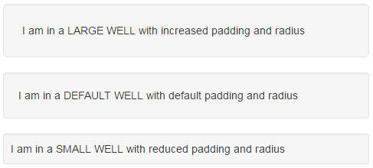

<div class="well well-lg">

    I am in a LARGE WELL with increased padding and radius

</div>

<div class="well">

    I am in a DEFAULT WELL with default padding and radius

</div>

<div class="well well-sm">

    I am in a SMALL WELL with reduced padding and radius

</div>

**Form controls in a well :** To place form controls in a well, simply wrap them in a <div> element which has the class well. We discussed forms in Part 20 of Bootstrap tutorial.   
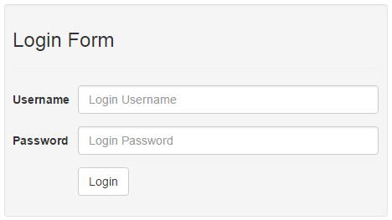

<div class="well well-sm">

    <h3>Login Form</h3>

    <hr />

    <form class="form-horizontal">

        <div class="form-group">

            <label for="inputUserName" class="control-label col-sm-2">Username</label>

            <div class="col-sm-10">

                <input class="form-control" placeholder="Login Username"

                        type="text" id="inputUserName" />

            </div>

        </div>

        <div class="form-group">

            <label for="inputPassword" class="control-label col-sm-2">Password</label>

            <div class="col-sm-10">

                <input class="form-control" placeholder="Login Password"

                        type="password" id="inputPassword" />

            </div>

        </div>

        <div class="form-group">

            <div class="col-sm-offset-2 col-sm-10">

                <button type="submit" class="btn btn-default">Login</button>

            </div>

        </div>

    </form>

</div>

**Changing the well background colour :** To change the background colour of the well, change the background-color style in the well class in your custom stylesheet.   
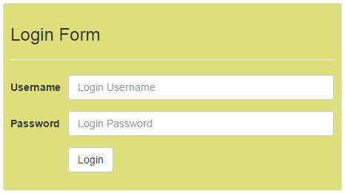

.well {

   background-color: #DDDF7C;

}